### AGGREGATE FUNCTIONs AND JOINs

**Inner JOIN**

**Introduction**

INNER JOIN is the most common type of JOINs. It creates a new result table based on the values in common columns from two or more tables. INNER JOIN returns a table that contains only matched rows that meet the specified join conditions.

Here is the syntax of the INNER JOIN clause:

SELECT columns

FROM table_A

INNER JOIN table_B ON join_conditions

In this syntax,

* *columns*: Column names from *table_A* or *table_B.*
* *table_A, table_B*: The names of the joined tables.
* *join_conditions:* It specifies the conditions to evaluate for each pair of joined rows.

A join condition generally takes the following form: table_A.column = table_B.column. The operator in this statement is usually an equal sign (=), but any comparison operator can also be used.

**💡Tips:**

* Note the ON keyword for specifying the INNER JOIN condition.
* Multiple join conditions can be written using AND or OR statements.

In addition, three or more tables can be combined using the INNER JOIN clause. The syntax used to join three or more tables is as follows:

SELECT columns

FROM table_A

INNER JOIN table_B

ON join_conditions1 AND join_conditions2

INNER JOIN table_C

ON join_conditions3 OR join_conditions4

...

Q: What is inner join?  
A: Retrieves records that have matching values in both tables involved in the join. This is the widely used join for queries.

### Example

Suppose you want to join the "employees" table and the "departments" table. In this example, an INNER JOIN has been created that is based on the *emp_id*columns in the two tables:

**Tables**

"employees" table:

### 

"departments" table:

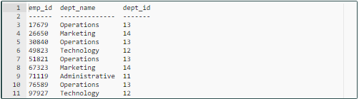

To understand easily how INNER JOIN works, we can use the following visual explanation. The intersection of the two tables represents the matching rows.

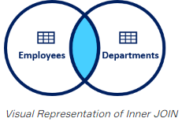

**Syntax**

The INNER JOIN keyword selects all rows from both "employees" and "departments" tables as long as there is a match between the columns. If there are records in the "employees" table that do not have matches in "departments", these records are not shown in the output.

query:

SELECT

employees.emp_id,

employees.first_name,

employees.last_name,

departments.dept_name,

departments.dept_id

FROM employees

INNER JOIN departments

ON employees.emp_id = departments.emp_id;

output:

emp_id first_name last_name dept_name dept_id

------ ---------- --------- ---------- -------

17679 Robert Gilmore Operations 13

26650 Elvis Ritter Marketing 14

30840 David Barrow Operations 13

51821 Linda Foster Operations 13

67323 Lisa Wiener Marketing 14

76589 Jason Christian Operations 13

97927 Billie Lanning Technology 12

As you can see from the output, the seven employees in the "employees" table have matches in the "department" table. The remaining three employees are not listed in the output. As you can see, employee ID 17679 is in both tables and matches, so it is included in our output table. On the other hand, employee ID 49714 is included in the employee table but not in the department table and there is no match. Therefore, employee ID 49714 is not included in the output table.